

**Police Verification Report (PVR) System**

User Manual

**By**



**National Informatics Centre, Howrah**

**CONTENTS**

|  |  |  |
| --- | --- | --- |
| SL.NO | TOPIC | PAGE NO. |
| 1. | Guidelines& Operator Manual For logging into the system | 1 |
| 2. | Guidelines for Data entry, Nodal Check, Accept/Reject **(DEO,NO)** | 5 |
| 3. | Guidelines for Report Generation **(DM, ADM, Sys Admin, District Level Officers, NO)** | 8 |
| 4. | Guidelines for System Administrator, Meeting Schedule, Notification Push and Fund Allocation**(Sys Admin, DM, ADM, DEO-D)** | 10 |
| 5. | **User Manual for MPR Portal** – Process Flow Diagram | 13 |
| 6. | System Requirements | 15 |
| 7. | Sitemap, Contact Us **(All Users)** | 17 |
| 8. | Operator Manual for Data Entry **(Block Level DEO)** | 19 |
| 9. | Operator Manual for Nodal Check **(Block Level NO, BDO, Sub-div level No, SDO)** | 21 |
| 10. | Operator Manual for Dashboard, Data View and Report Generation **(DM,ADM,DEO-D,SDO,BDO)** | 23 |
| 11. | Operator Manual for System Administrator (Super Admin) | 29 |
| 12. | Operator Manual for Meeting Schedule, Notification, Funds Allocation **( District Level Officers)** | 35 |

**Guidelines & Operator Manual For logging into the system**

**(All Users)**

1. **Procedure for Logging into the system (All Users):**

**1. First Time Login:**

The username for log in is the personal email address that the user will provide to the System Administrator during account creation. A one-time password will be provided to the user which they can find in their mail inbox after successful account creation from the administrator’s end. The user when tries to log in with that username and one-time password, needs to change their password for further logging into the system.

**2. Forget password:**

If the user forgets his/her password, then he needs to head on to the Forget Password option where he/she needs to enter in his/her email address and a onetime password will be sent to his/her email address. By validating that OTP user will be redirected to the reset password portal and from there user can successfully change his/her password.

**3. User Login:**

The user needs to put the login details along with the captcha to bypass the security check and login successfully.

1. **Operator Manual for Login:**
   1. **First User:**

**STEP 1: This is the landing page 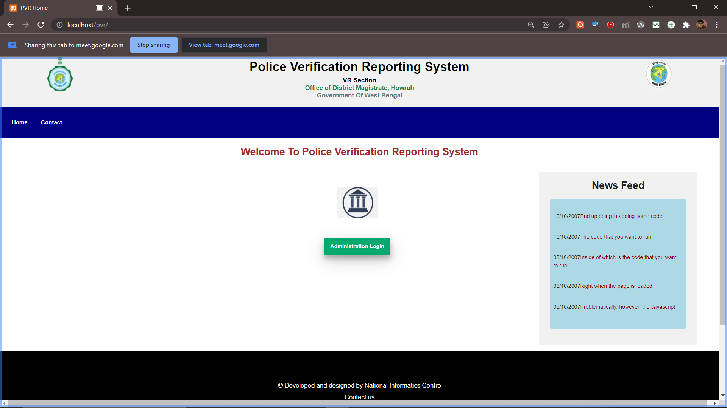 STEP 2:** User puts email-id, one-time password and captcha for login.

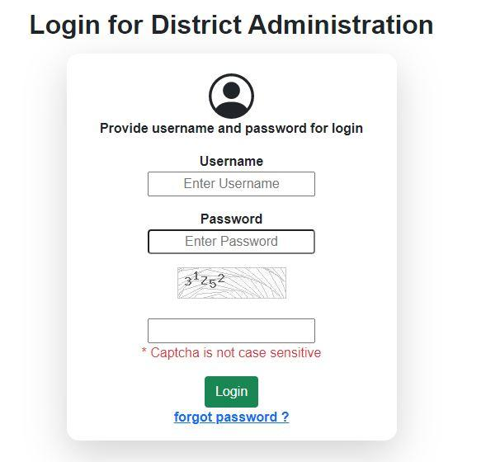

Forget Password

Login

Captcha

Password

Username /Email

**STEP-3:**As this is a new user, so create password for the first time opens so that user can change in the default password for further login.

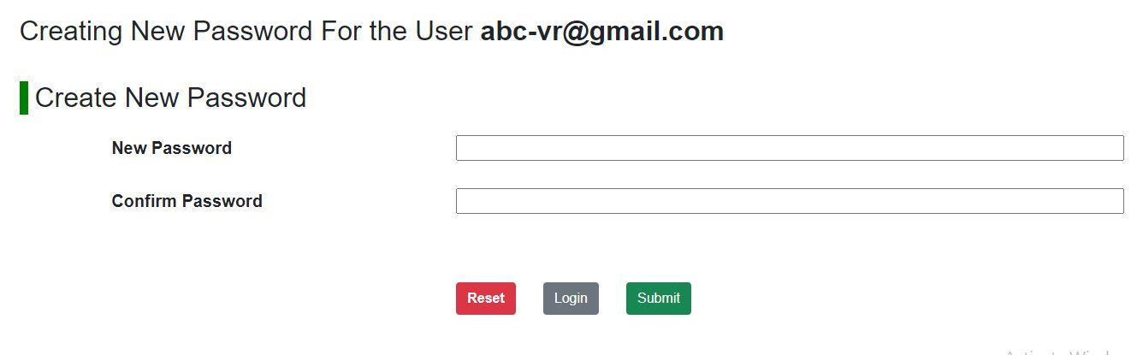

New password set

**STEP-3:** New User’s password will be updated successfully and that user can login from there.

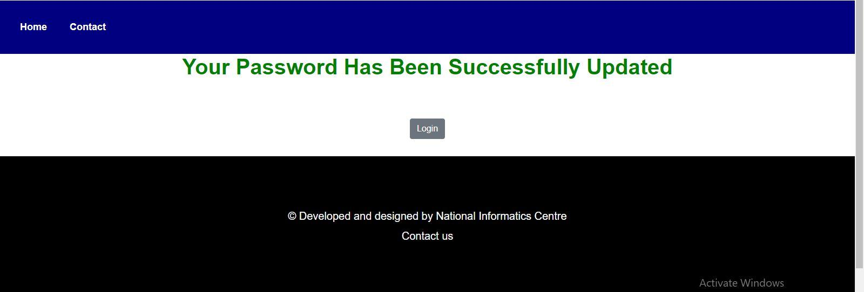

Login Button

**STEP-4: Now User will login.**



**Guidelines for Super Admin**

1. **Procedure for Super Admin:**

The super admin is the prime administrator who have all the important privileges

* 1. **Privilege:** The super admin can see all the application entries into the portal.
  2. **Activity Log:** The admin can see all the activity logs of all users.
  3. **Password Change Activity:** The admin can see when the password is changed and can interact accordingly.
  4. **Add User:** The admin can also add more users whenever required.
  5. **User Monitoring:** The admin can see all the users existing in the system.
  6. **Monitoring Report:** Monitoring Report option shows the Quarterly report.
  7. **Daily Application Report:** Daily application report shows the daily report of all the applications.

1. **Work Flow for Super Admin:**

This is a detailed and shown pathway for super admin.

* 1. **Check All Details:  
     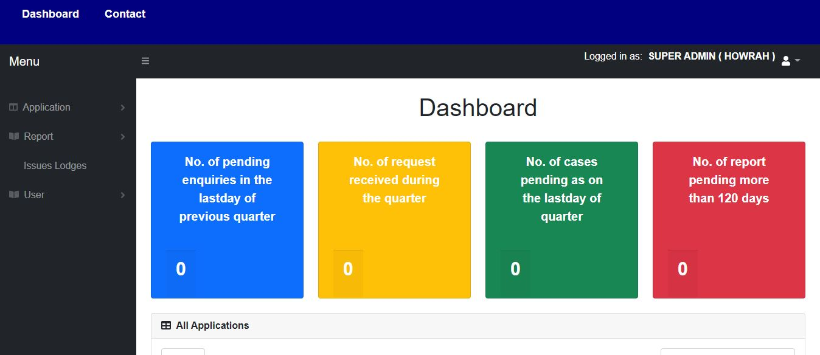**
  2. **Add User:**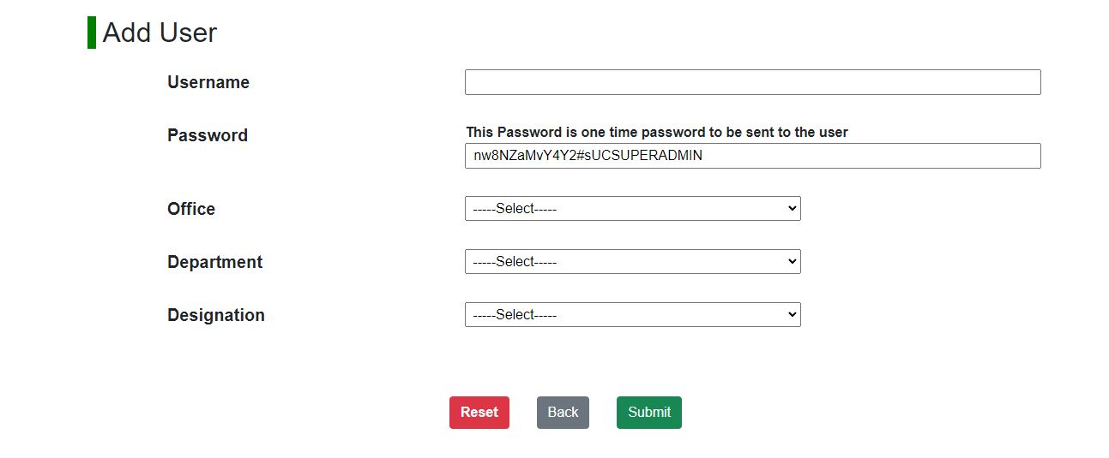
  3. **One-time Password Set:  
     **
  4. **Generate Monitoring report:**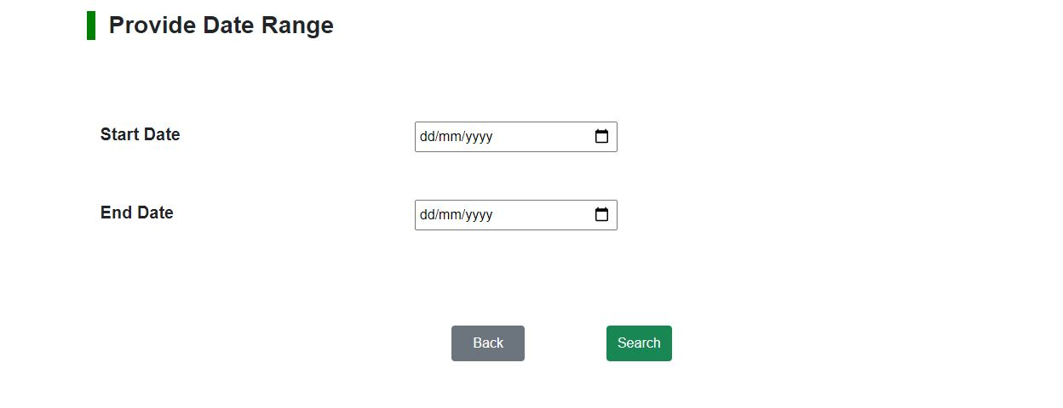
  5. **Generate Daily Application Report: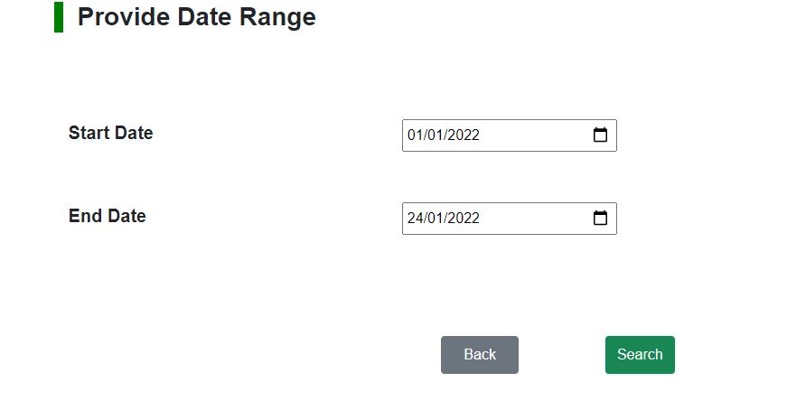  
     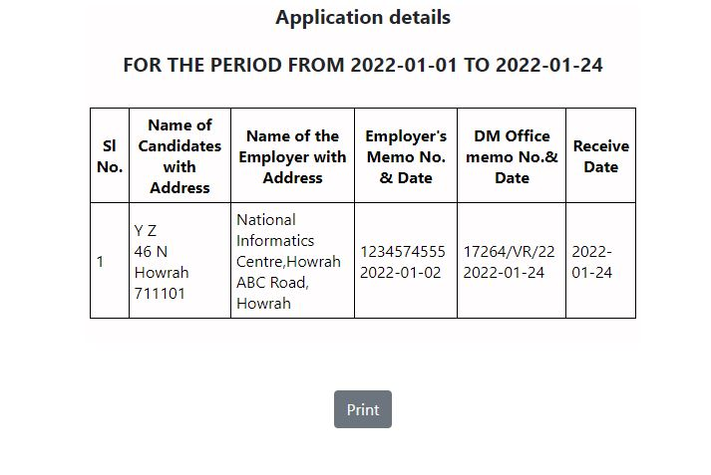**

**Guidelines for Data Entry Operator**

1. **Procedure for DEO:**
   1. **New Application:** You can generate new applications.
   2. **Check Status:** The Check Status option allows to search the application status in three ways - By Memo No, By Receipt No and By Reference No. He/she can provide the corresponding numbers to search the statuses.
   3. **Update Application:** The generated applications can be updated.
   4. **Monitoring Report**: Monitoring Report option shows the Quarterly report between the given date range. We can provide the start and end date and search the corresponding quarterly report.
   5. **Daily Application Report:** Daily Application Report option shows the Daily report between the given date range. We can provide the start and end date and search the corresponding daily report.

1. **Work Flow for DEO:**
   1. **Application Submission:**
      1. 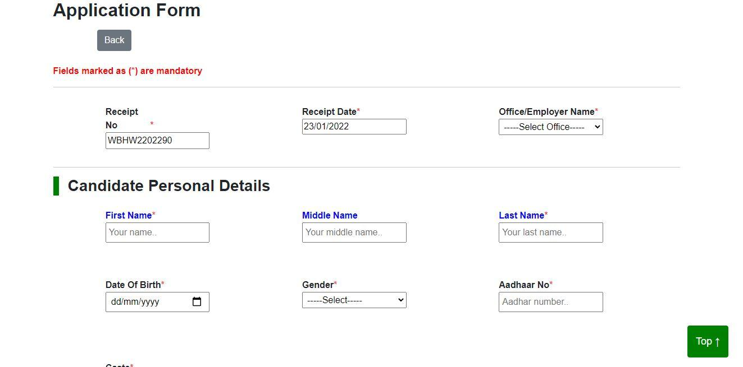**Check all input fields:**

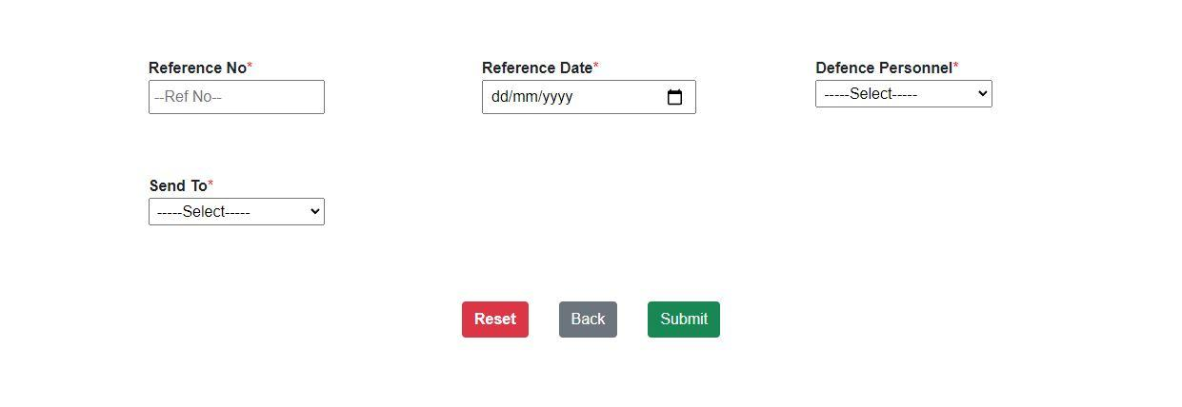

* + 1. **Send Notification to OCVR**
  1. **Adding Office:**
     1. **Check all input fields**
     2. 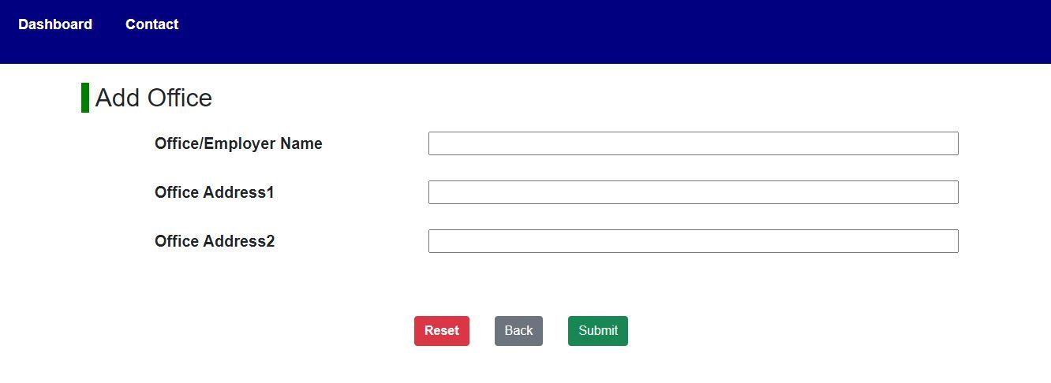**Add Office**
  2. **Updating Applications:**
     1. 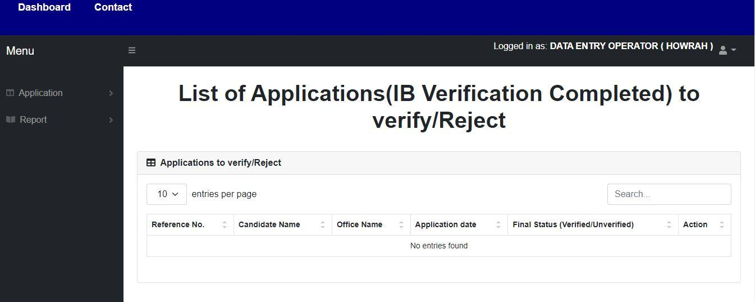**Verify or Reject Applications**
     2. **Send notification to OCVR**

**Guidelines for Officer in Charge**

1. **Procedure for OCVR:**
   1. **Check Status:** The Check Status option allows to search the application status in three ways - By Memo No, By Receipt No and By Reference No. He/she can provide the corresponding numbers to search the statuses.
   2. **Add Office:** The Add Office option allows to add any new office. He/she can provide the Office/Employer Name and the Office Address here.
   3. **Verified letter to employer:** The OCVR verifies the letter to the employer.
   4. **Application approval:** This option allows to approve the submitted applications.
   5. **Monitoring Report:** Monitoring Report option shows the Quarterly report between the given date range. We can provide the start and end date and search the corresponding quarterly report.
   6. **Daily Application Report:** Daily Application Report option shows the Daily report between the given date range. We can provide the start and end date and search the corresponding daily report.
2. **Work Flow for OCVR:**
   1. 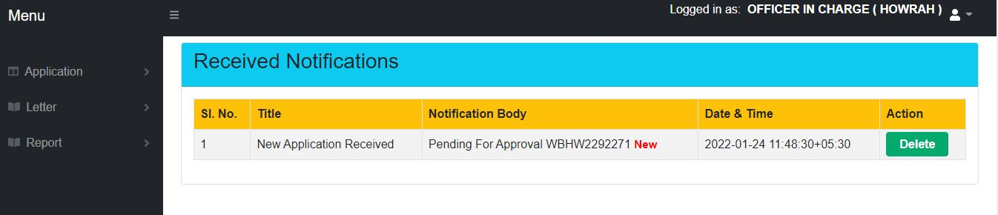**Application Procedure:  
      Notification Generated:**
      1. 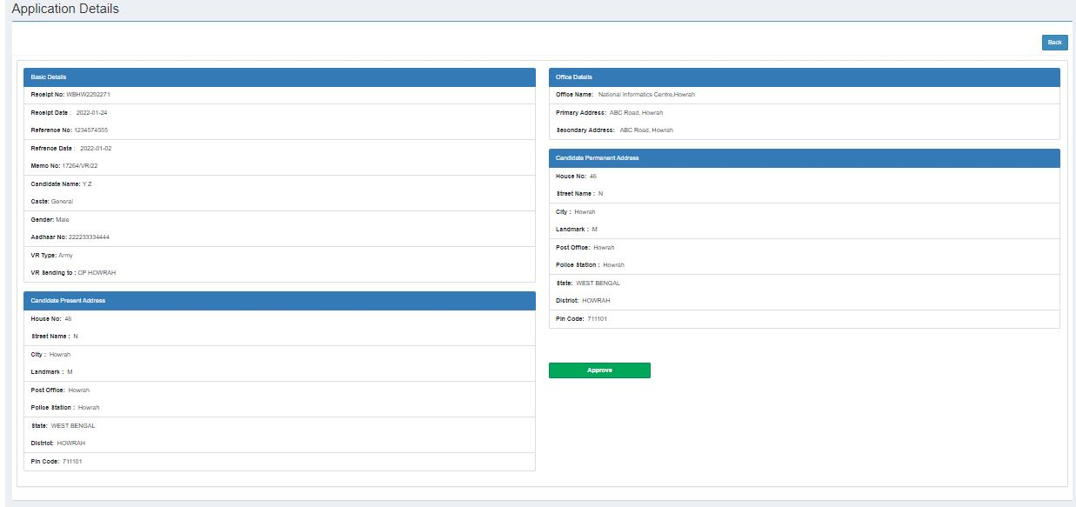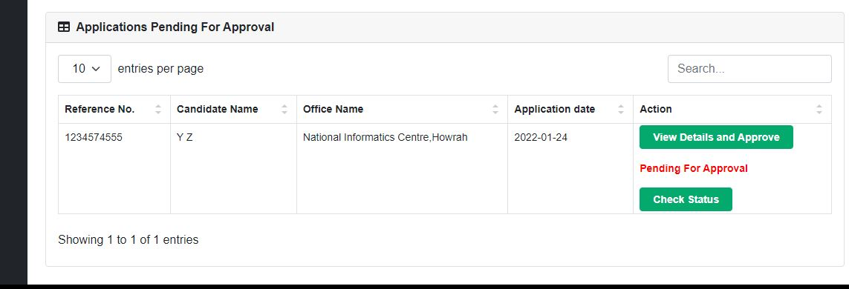**Approve Application**
      2. 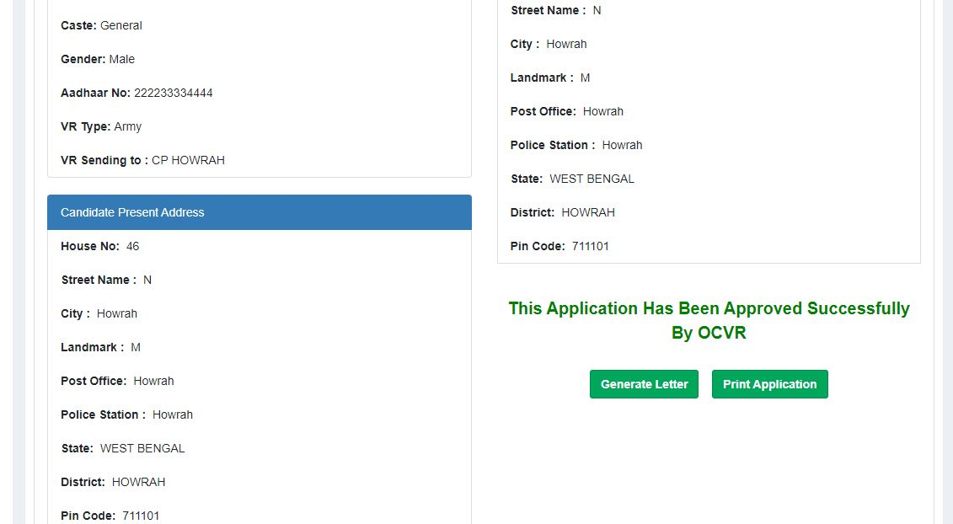**Send Notification to VR**
   2. **Application Search and Status:**
      1. 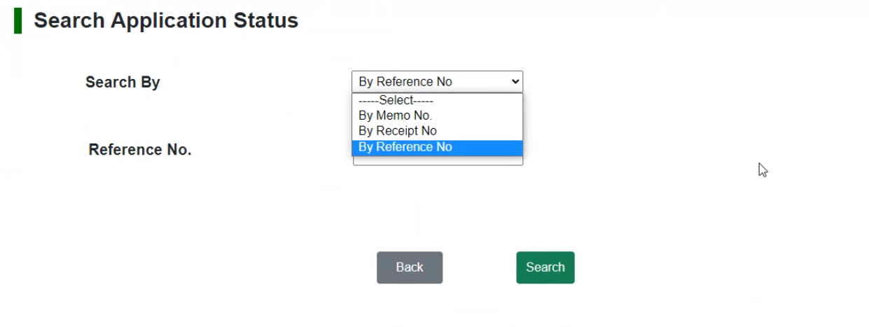**Match Search Key(Receipt No.,RefNo.,Memo No.)**
      2. 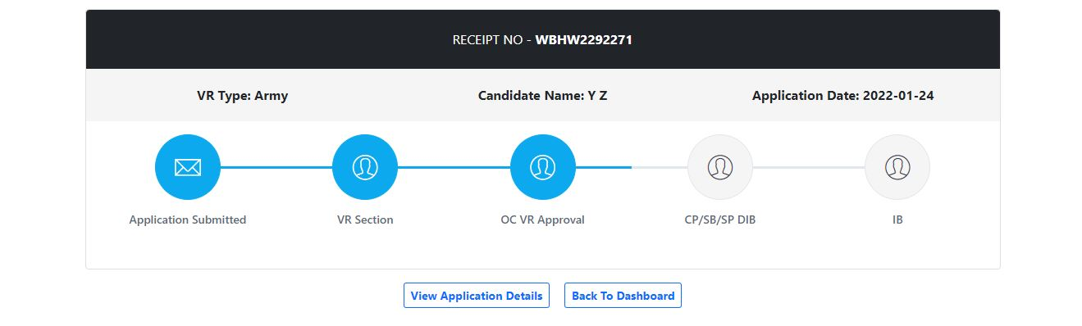**Display Application Status**
   3. 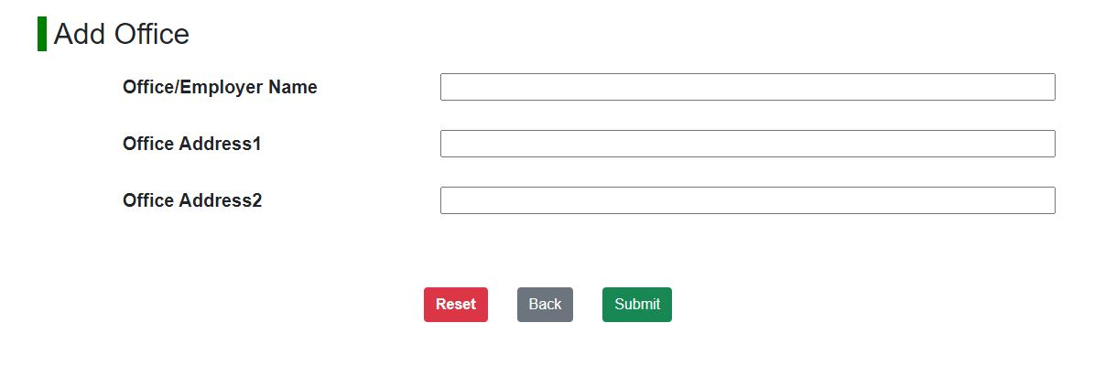**Adding Office:**
   4. 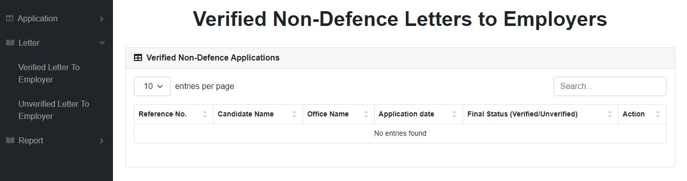**Letter:**
   5. **Application Report:**
      1. 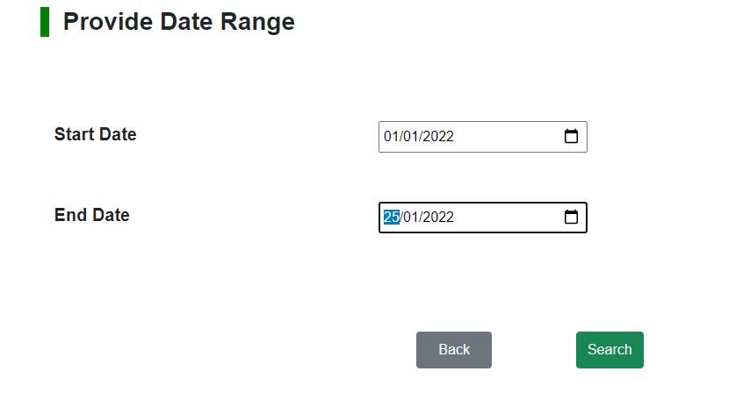**Monitoring Report:**

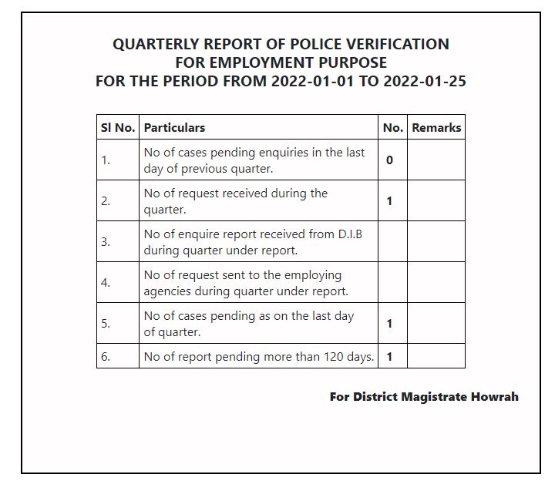

* + 1. **Daily Application Report:**



**User Manual for PVR Portal –**

**Process Flow Diagram**

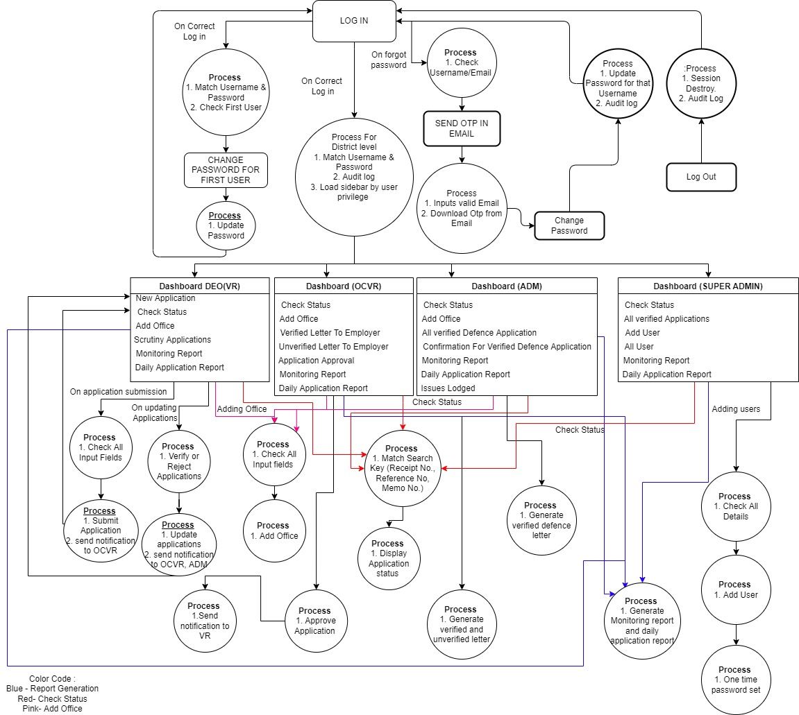



|  |  |
| --- | --- |
| **OPERATING**  **SYSTEM** | UNIX,LINUX,  WINDOWS,MAC-OS |
| **PROCESSOR** | 1GHz |
| **RAM** | 2Gb |
| **BROWSER** | Chrome,Mozilla Firefox, Microsoft Edge,Internet Explorer, Safari |
| **SERVICES TO BE ENABLED** | JavaScript, Cookie, Cache |



**Contact Us** can be accessed from the Contact option in the navigation bar which shows the contact details and information about the PVR portal and a feedback form is available for providing issues and feedback by the users.

